Dispatch Bot Flow

* Excel Sheet containing the data of shipment from the supplier. This sheet of data is uploaded in the database through portal.

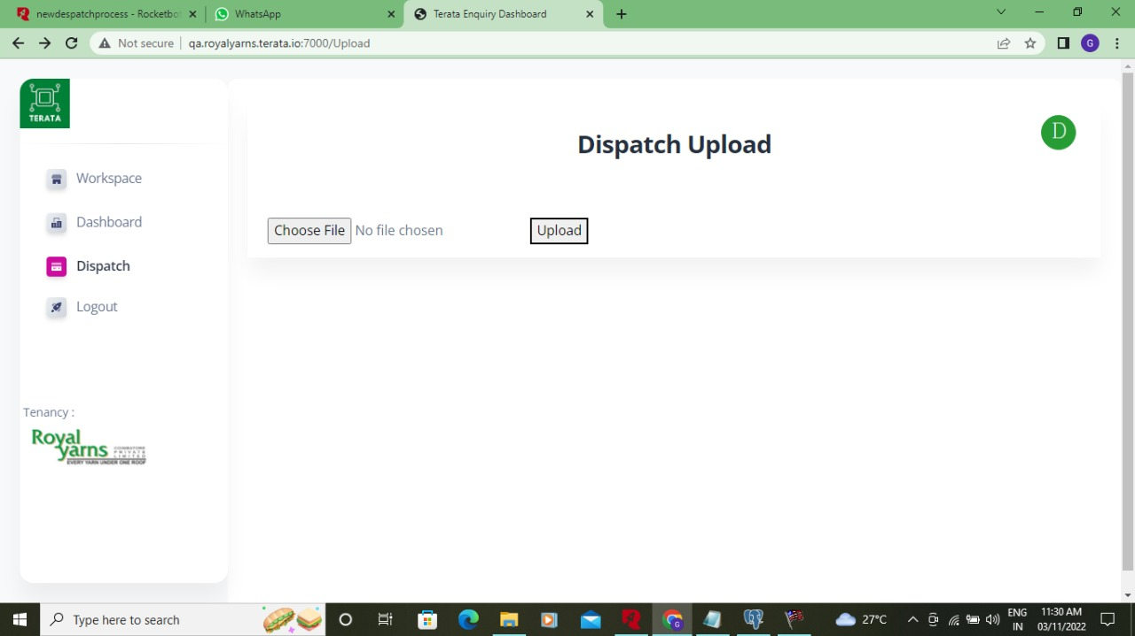

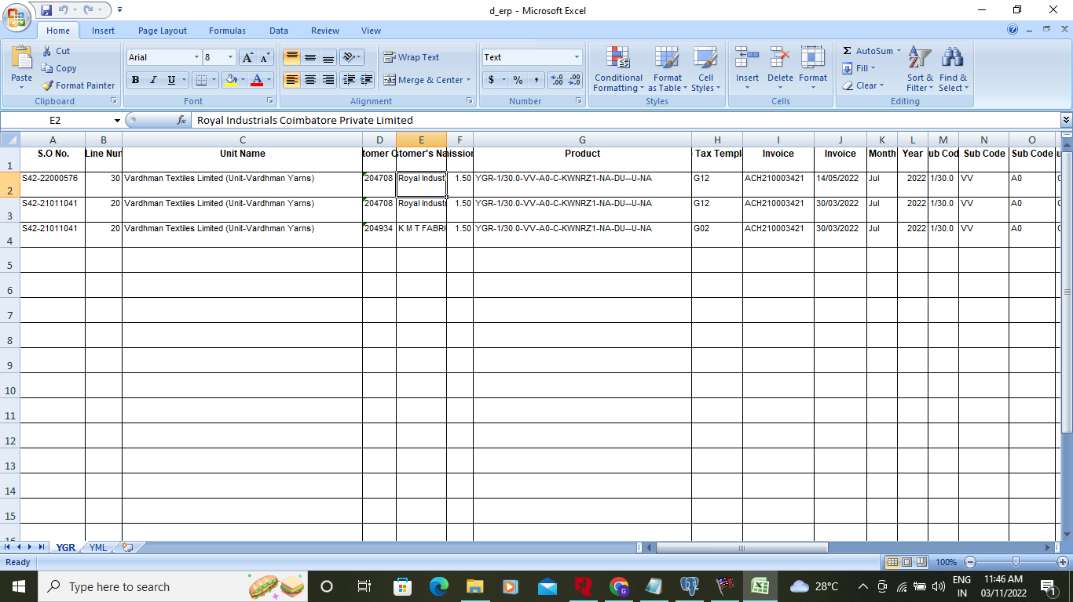

New Dispatch Process:

This bot reads the data from the database as a form of key value pair of datas. With the process status ‘0’.It reads the data with the row index and enter the values in the erp. Then the process status changes from ‘0’to ‘1’.

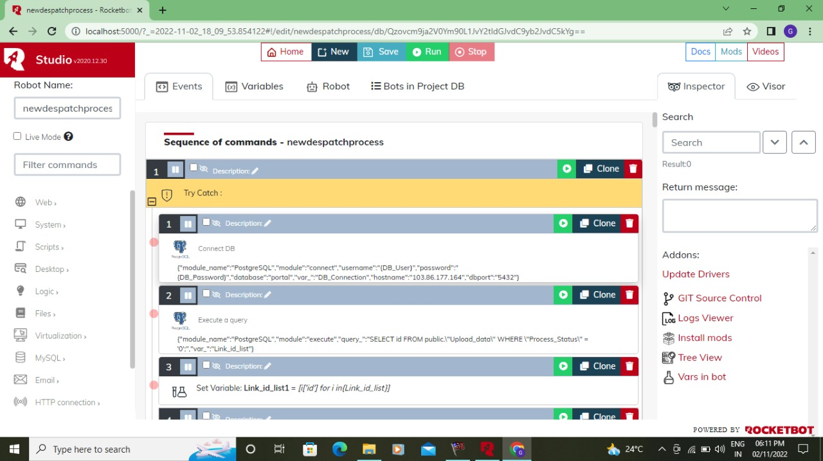

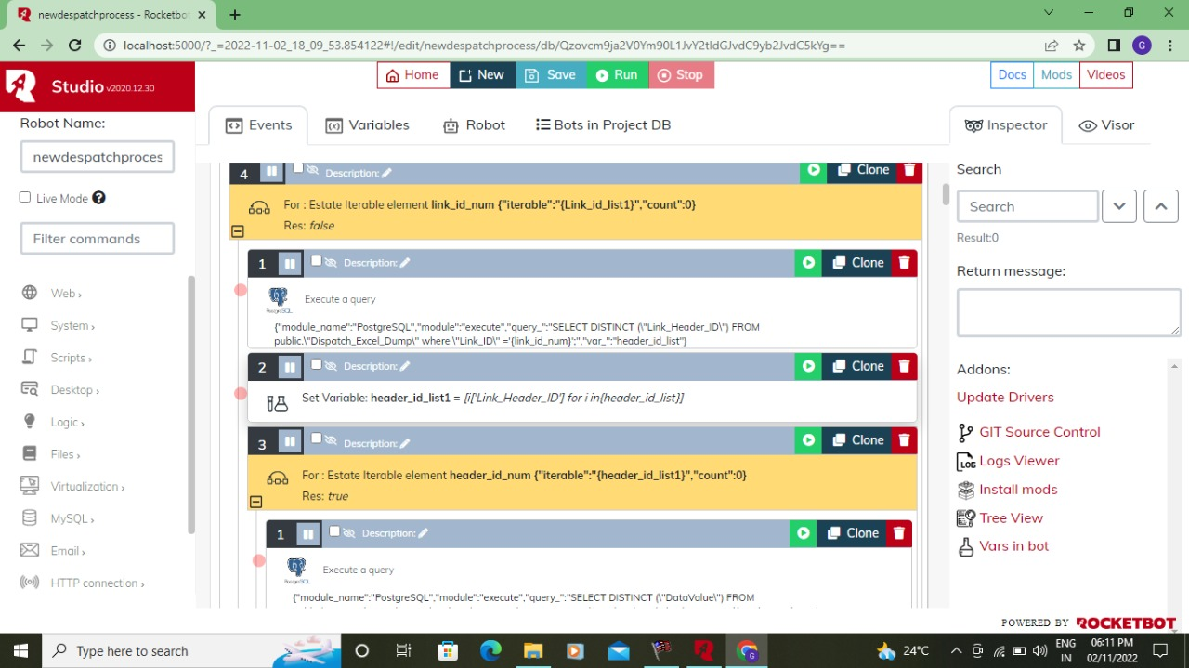

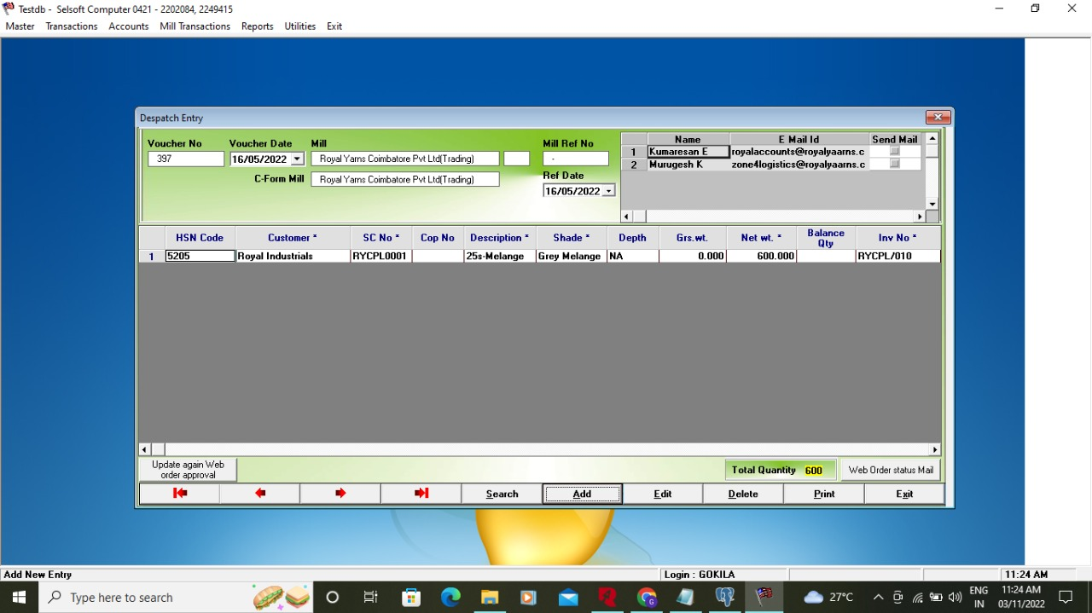

New Dispactch Process2:

This bot enters the invoice from mill form in the erp. Then it enters the Invoice No from mill and save in the database. And this check the final amount with the taxes included for the Invoice.

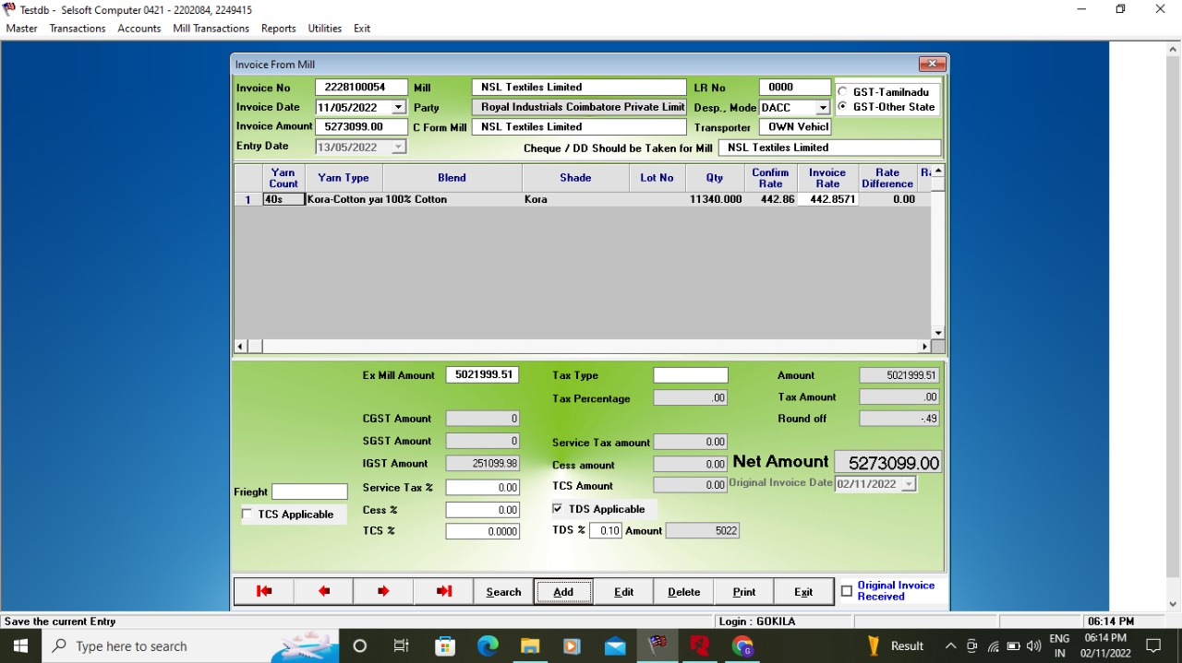

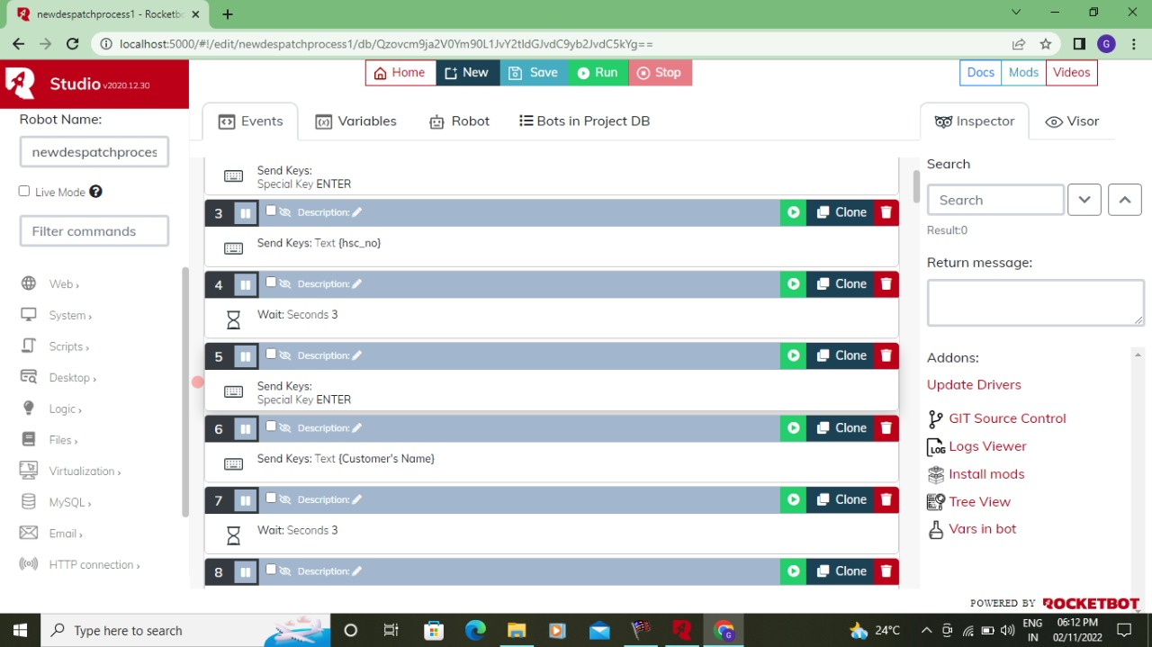

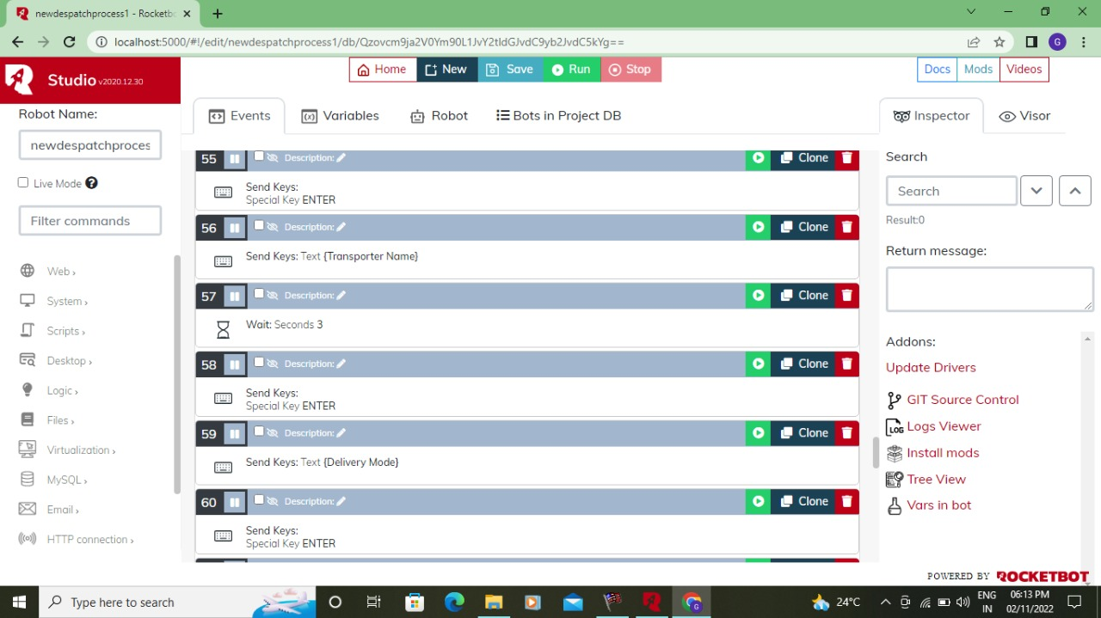

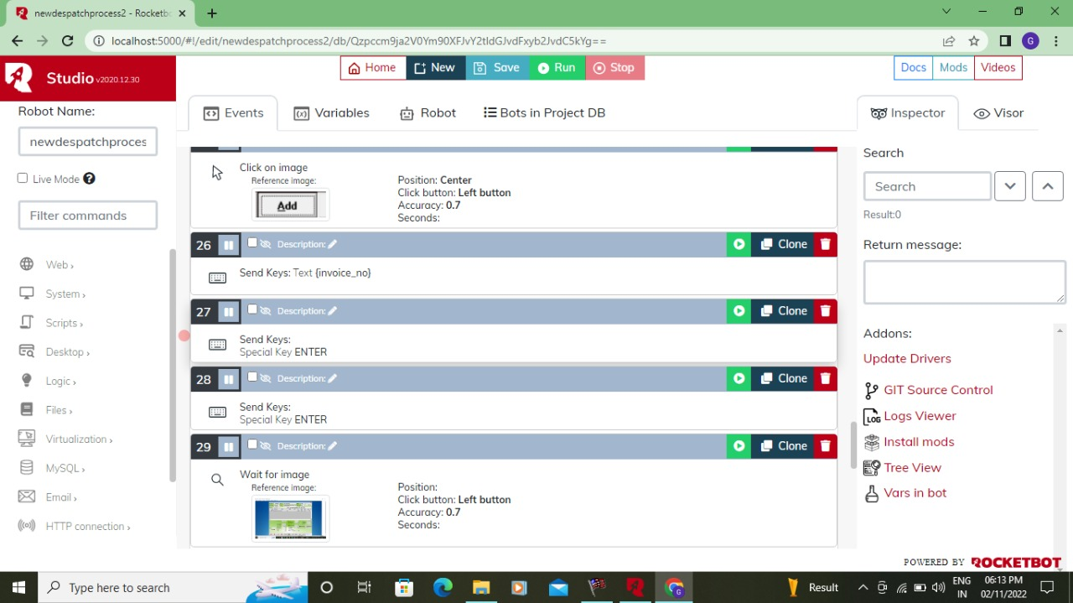

Strucked in the Flow:

In the erp the screen the search pattern was based on the one of the column. But it needs to be multiple search to complete our flow so we requested for the change but they denied the change.

